**Your Name: Purnabhishek Sriapthi**

**Grading Policy: In order to get credit for each screenshot,** you **MUST** have the repository named as ***BAN540_YourLastName*** with ***Chapter03DataSet_YourLastName*** and ***BAN540_Lab1_YourLastName*** in it. The repository and data files **MUST** be clearly shown in your screenshots as my examples below. If not, you will get ZERO for that particular screenshot which doesn’t show them clearly.

**Hint:** If your **screenshot layout** is not the same as mine, please click on **View->Restore Default View** as shown in the following screenshot.

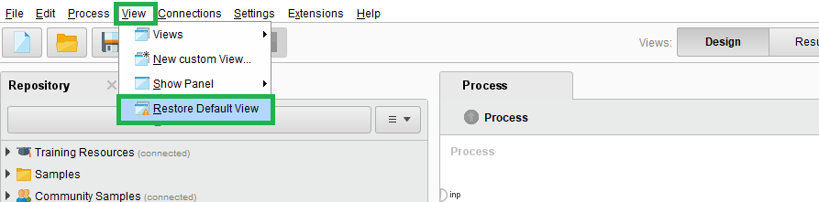

**screenshot #1 (5 points)**

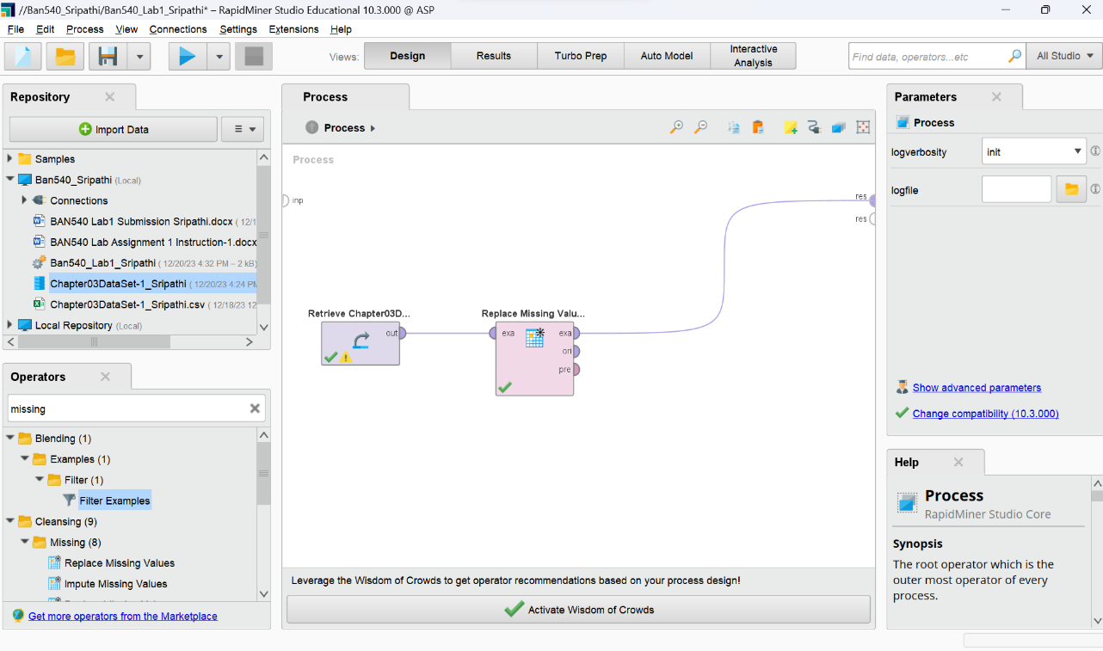

**screenshot #2 (5 points)**

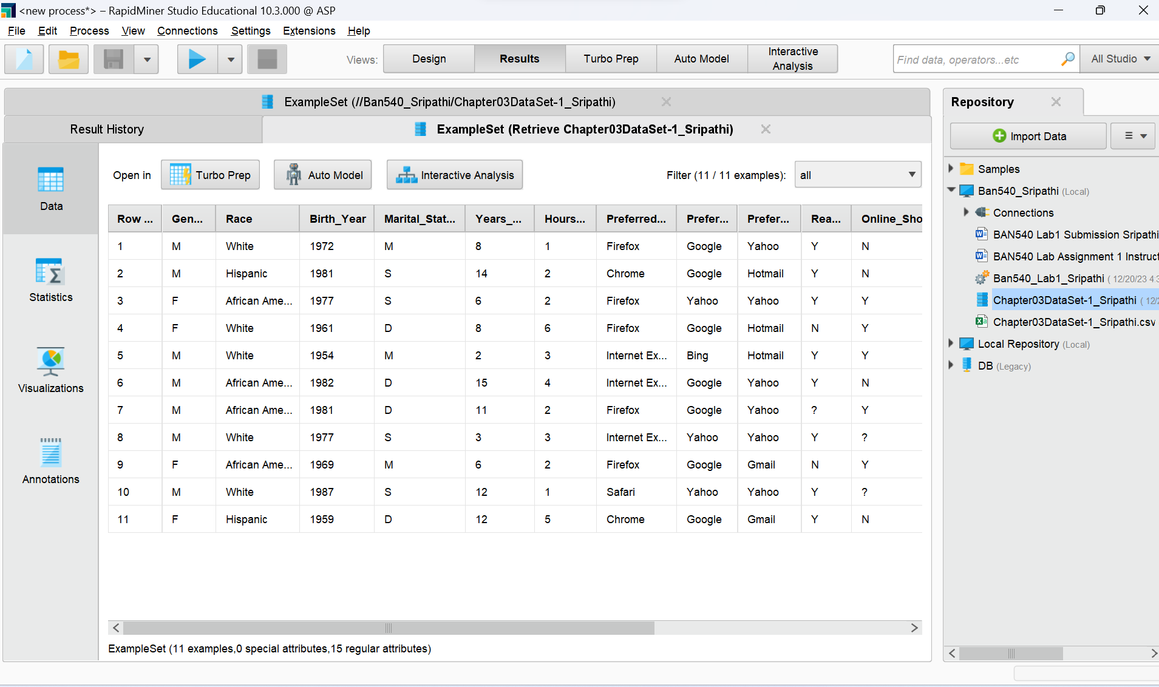

**Hint: If your screenshot is not wide enough to display all the columns in the result perspectives, please scroll to the very left side so that *Row No.*** **column is shown on your screen. As long as your *Row No.* and *Online_Gaming*** **columns are visible, you are good to go.**

**screenshot #3 (2 points)**

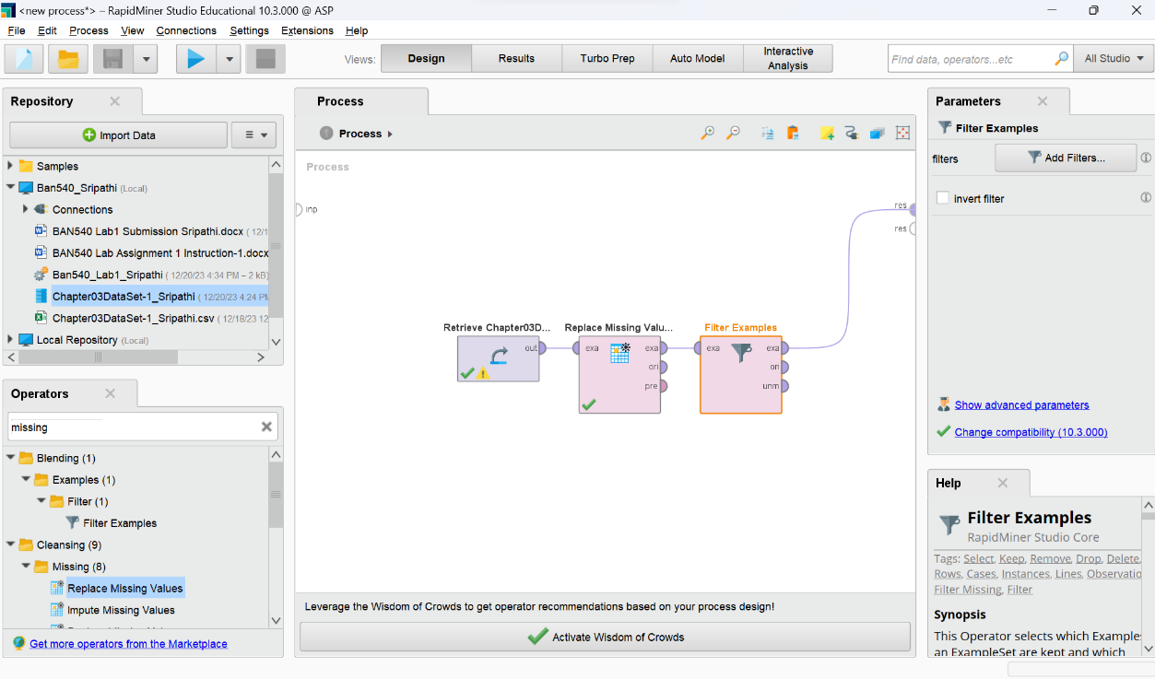

**screenshot #4 (3 points)**

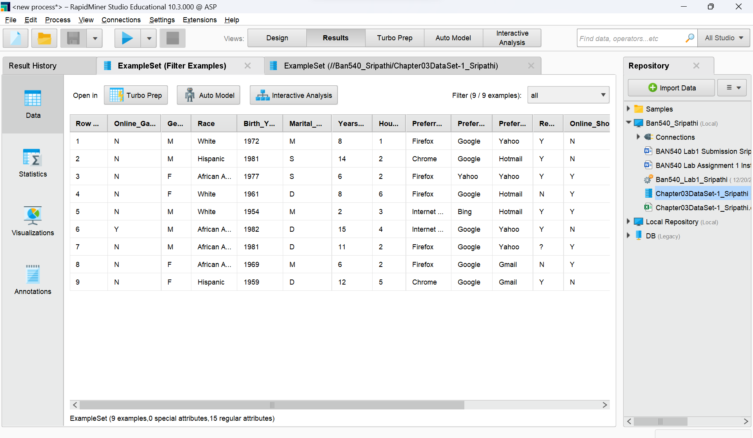

**Hint: If your screenshot is not wide enough to display all the columns in the result perspectives, please scroll to the very left side so that *Row No.*** **column is shown on your screen. As long as your *Row No.*** **column is visible and the nine observations shown on your screenshot are correct, you are good to go.**

**screenshot #5 (2 points)**

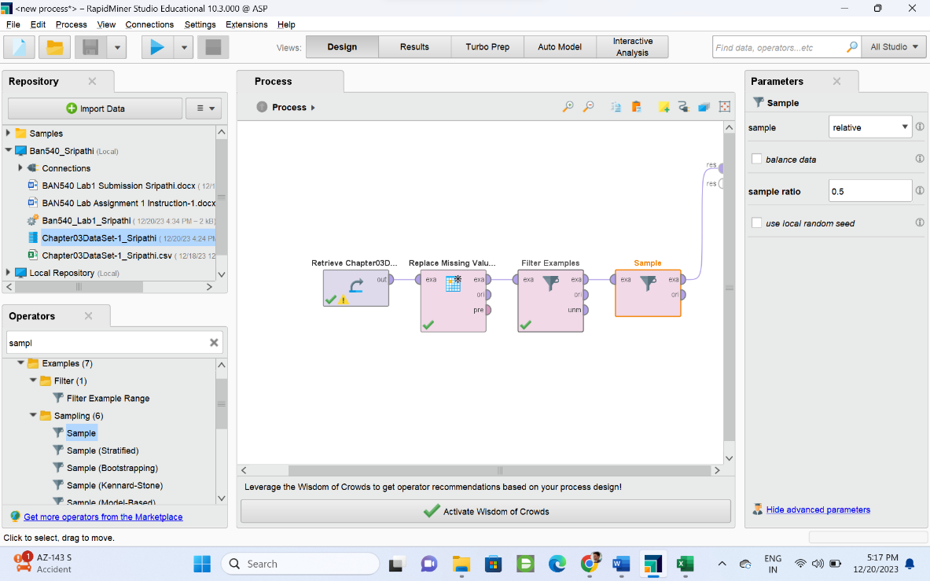

**screenshot #6 (3 points)**

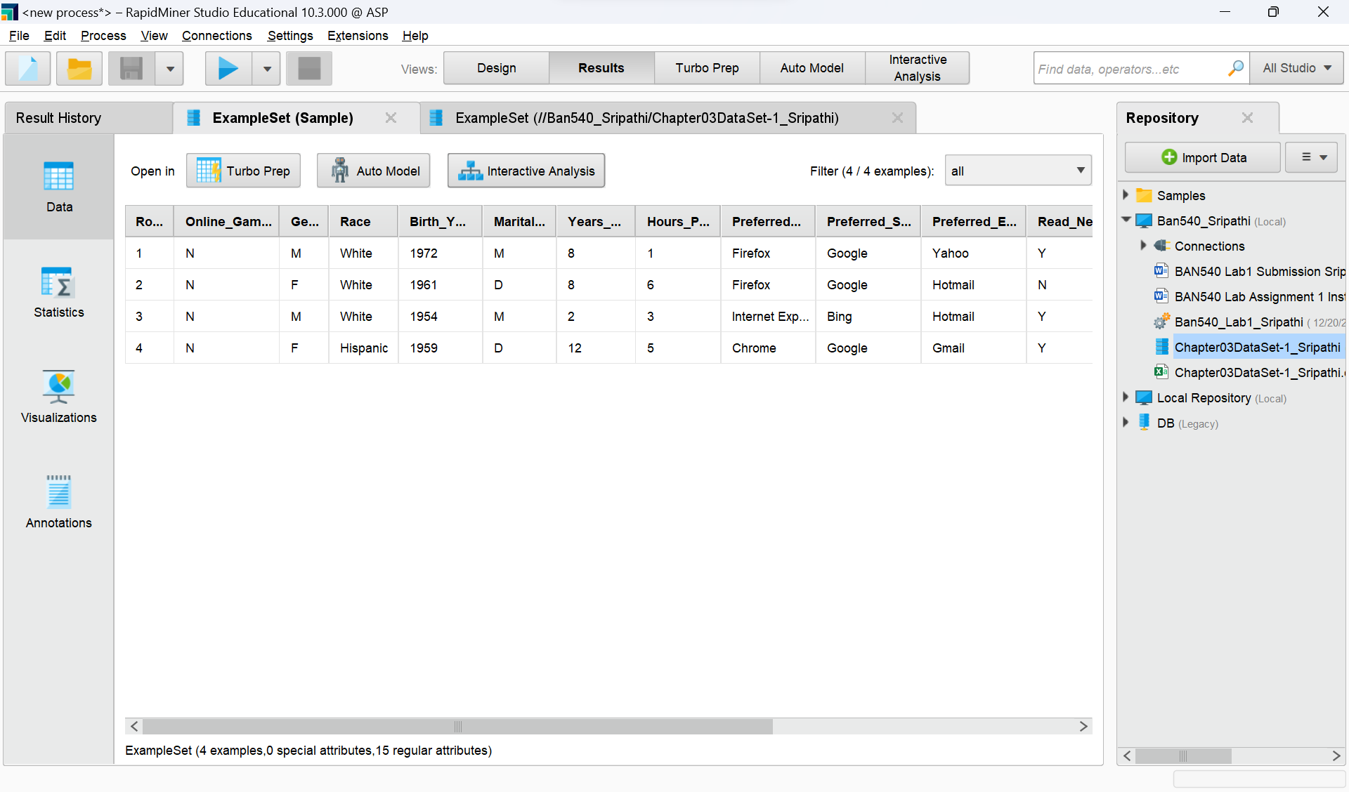

**Hint: If your screenshot is not wide enough to display all the columns in the result perspectives, please scroll to the very left side so that *Row No.*** **column is shown on your screen. As long as your *Row No.*** **column is visible and there are 4 or 5 observations displayed, you are good to go.**

**screenshot #7 (5 points)**

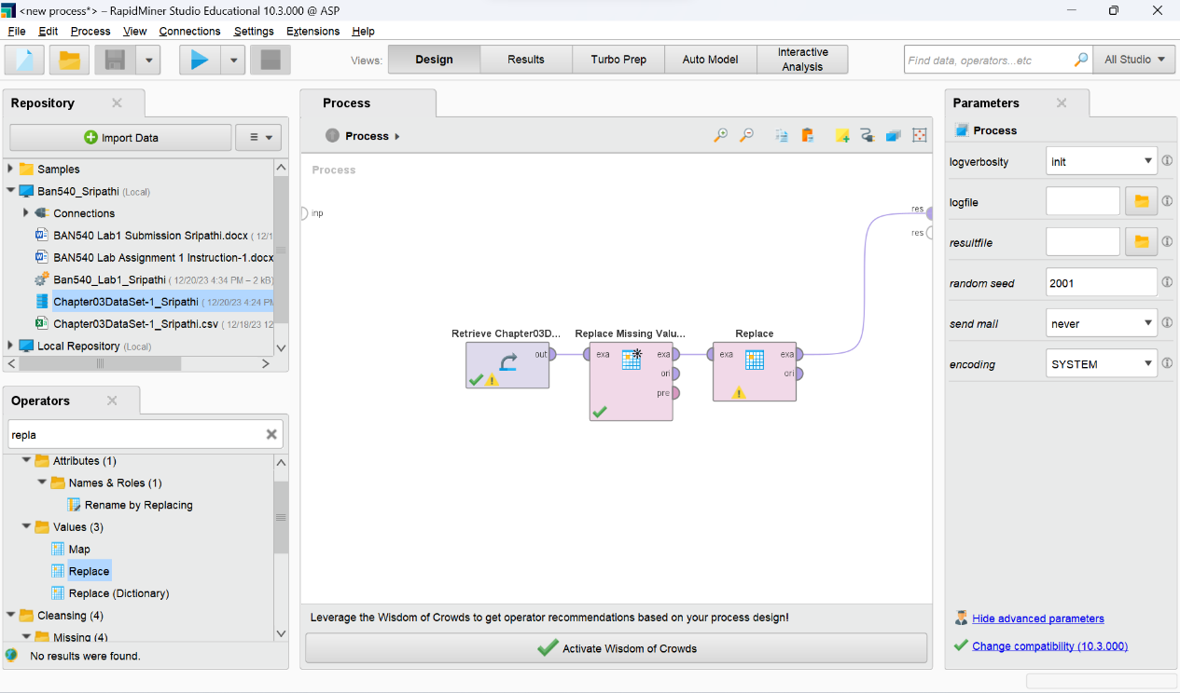

**screenshot #8 (5 points)**

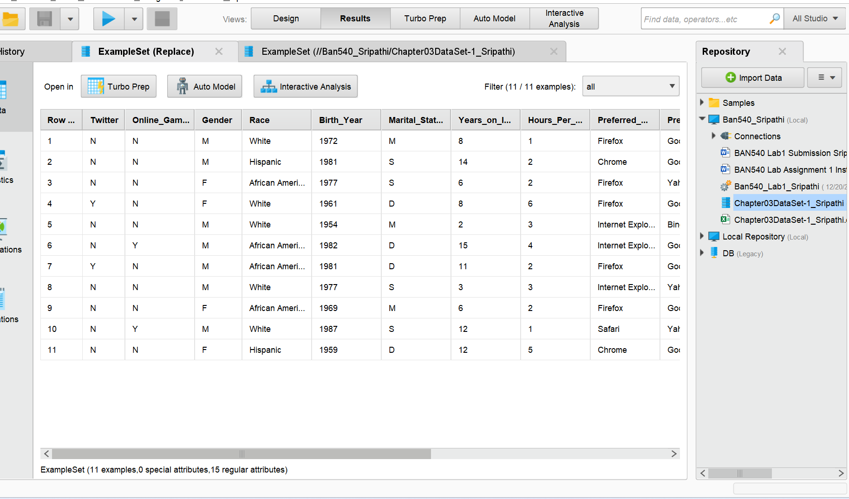

**Hint: If your screenshot is NOT wide enough to display all the columns in the result perspectives, please scroll to the very left side so that *Row No.*** **column is shown on your screen. As long as your *Row No.*** ***and*** **Twitter** **columns are visible, you are good to go.**

**Now you are done with Lab Assignment 1, please make sure to fill in your name on the first page of this document, and rename this document to reflect your own last name before submitting it to Canvas.**